2020 AUTUMN SPECIAL OFFERS
From September 24th is mandatory for guests to wear a face covering in all areas of our guest house, unless eating or drinking. Aside from this, we are still operating the procedures that we implemented back in August when we reopened. We have had wonderful feedback about our COVID measures from guests who have stayed with us so far. You can check the COVID policies on our website.
We look forward to welcoming you for an Autumn break!
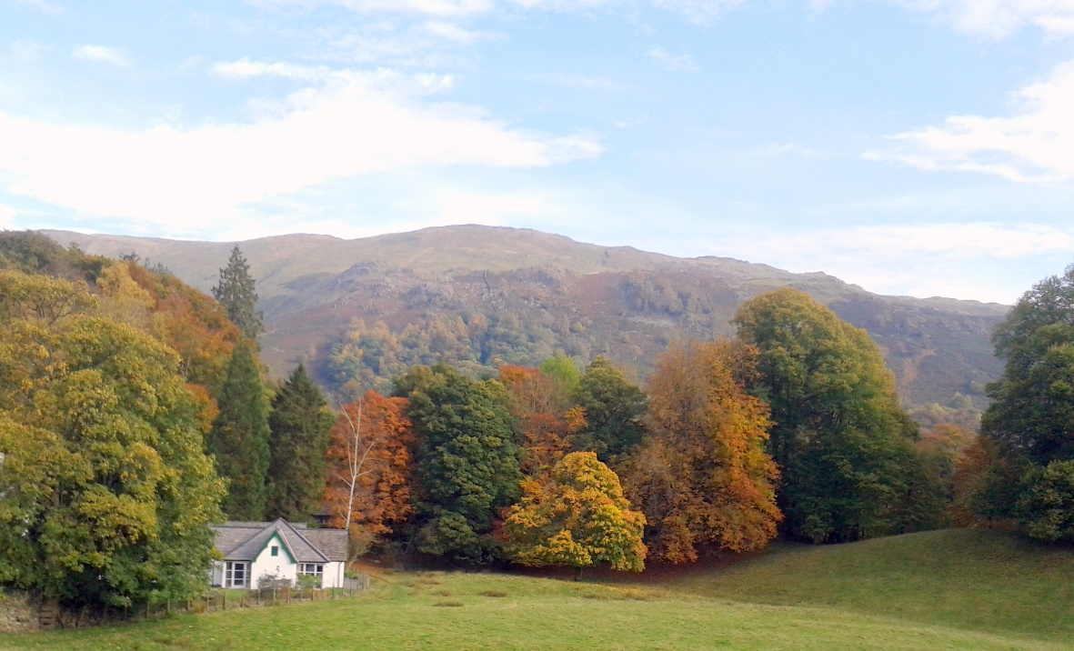
Please book by calling 015394 35389 or emailing info@glenthorne.org
October 2nd, 3rd & 4th (3-day break) £210.00 p.p. Dinner, B&B / £150.00 p.p. B&B
October 5th to 9th (4-day break) £280.00 p.p. Dinner, B&B / £200.00 p.p. B&B
October 16th, 17th & 18th (3-day break) £210.00 p.p. Dinner, B&B / £150.00 p.p. B&B
October 25th, 26th & 27th (3-day break) £210.00 p.p. Dinner, B&B / £150.00 p.p. B&B
November 5th, 6th & 7th (3-day break) £195.00 p.p. Dinner, B&B / £135.00 p.p. B&B
November 9th to 13th (4-day break) £260.00 p.p. Dinner, B&B / £180.00 p.p. B&B
November 13th, 14th & 15th (3-day break) £195.00 p.p. Dinner, B&B / £135.00 p.p. B&B

