2019 AUTUMN SPECIAL OFFERS
These offers are only available for bookings made over the phone 015394 35389 or emailing info@glenthorne.org

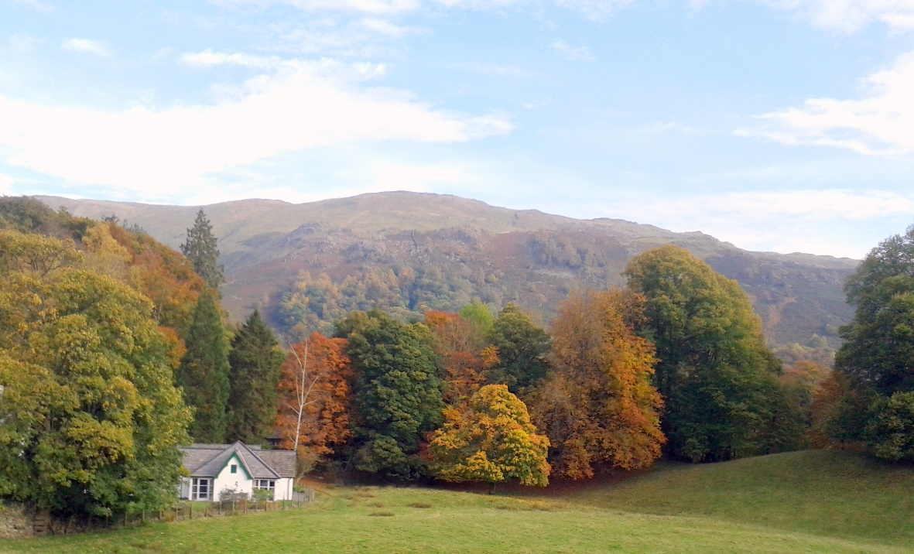

October 28th – November 1st (4 day break) £285.00 p.p. Dinner, B&B
November 11th – 15th (4 day break) £275.00 p.p. Dinner, B&B
***Add Sunday 10th to your booking for £50.00 p.p. B&B ONLY***
November 18th – 22nd (4 day break) £275.00 p.p. Dinner, B&B
***Add Sunday 17th to your booking for £50.00 p.p. B&B ONLY***
November 25th – 28th (3 day break) £205.00 p.p. Dinner, B&B
***Add Sunday 24th to your booking for £50.00 p.p. B&B ONLY***

