AUTUMN SPECIAL OFFERS
There are few places in the United Kingdom that glow with the beauty of the Lake District at this time of the year. Come and see the trees turn to their autumn colours whilst you enjoy a relaxing break at Glenthorne.
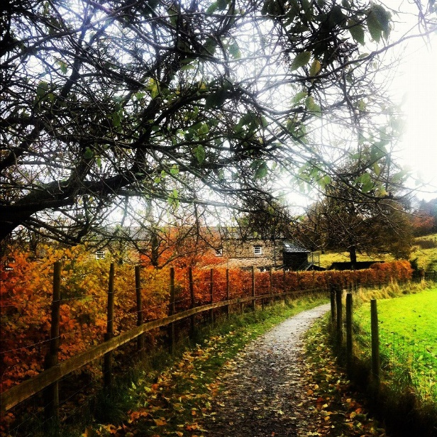

Four nights Monday 22nd to Friday 26th October
Dinner, B&B £285.00 per person / B&B £200.00 per person

Four nights Monday 29th October to Friday 2nd November
Dinner, B&B £280.00 per person / B&B £200.00 per person

Two nights Wednesday 7th & Thursday 8th November
B&B £95.00 per person

Four nights Monday 12th to Friday 16th November
Dinner, B&B £275.00 per person / B&B £200.00 per person
B&B £190.00 per person

