Quaker Spiritual Healing in the UK & Kenya

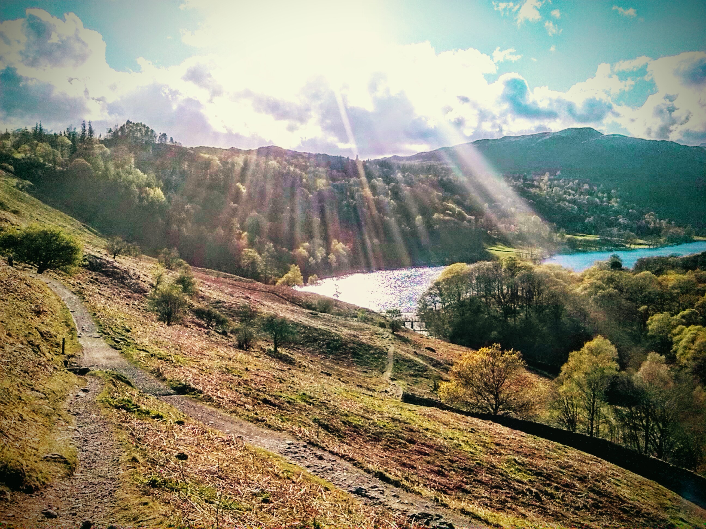
Saturday 14th May 10.00am – 4.00pm at Glenthorne

Led by Jim Pym & Patrick Muganda

supported by Terry Winterton & Allan Holmes

Quaker Spiritual Healing can open the doors of our heart and let the Light in. This will be a day for sharing our experiences of spiritual healing. Patrick Muganda is General Superintendent of Kakamega Yearly Meeting in Kenya. Jim Pym & Allan Holmes are Quaker Spiritual Healers in the Uk. Terry is the Quaker Friend in Residence at Glenthorne, an experienced group facilitator and a registered counsellor.

A donation of £10 is suggested to cover room hire cost and drinks. Please bring your own packed lunch.

To book please contact Glenthorne Quaker Centre, Easedale Road, Grasmere, LA22 9QH.

T: 015394 35389 E: info@glenthorne.org W: www.glenthorne.org

