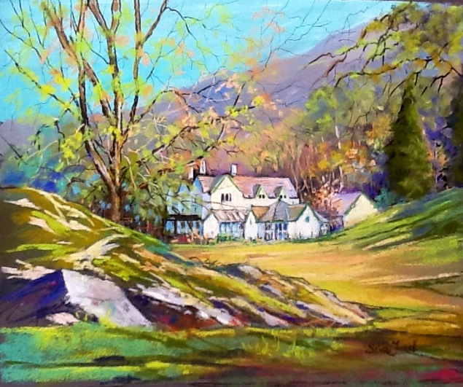

SPECIAL INTEREST HOLIDAYS PROGRAMME 2015

16th – 20th March Patchwork for Fun Gillian Waddilove

23rd – 27th March Transformative Life Writing Retreat Alison Lock

27th April – 1st May Boot, Boat and Goat T. Winterton and G. Ogilvie

1st – 4th May Painting and Sketching in the Lakes Sue Ford

15th – 17th May Lakeland Flora & Fauna Roy Vickery

18th – 22nd May Circle Dance Anne-Lise Kryger

29th – 31st May Exploring the Spiritual Path Linda Hoy and Annie Lord

12th – 14th June Nourishing the Soul Linda Hoy

15th – 19th June Quakerly Yoga Mary Cleary

3th – 5th July Trees & Landscape Letta Jones

10th – 12th July Inspired by the Lakes – Textile workshop Helen Parrott

17th – 19th July The Spiritual Journey in the Gospel of Mark Janet Scott

3rd – 7th August Painting and Sketching in the Lakes Sue Ford

17th – 21st August Dru Yoga Julia Slater

24th – 28th August Painting and Sketching in the Lakes Sue Ford

4th – 6th September Inspiration from the Mystics Roswitha Jarman

11th – 13th September Transforming Quakerism Ben Pink Dandelion

18th – 20th September Allowing Forgiveness & Healing A. Holmes and M. Partington

5th – 9th October Boot, Boat and Goat T. Winterton and G. Ogilvie

16th – 18th October Experiment with Light Leaders TBC

19th – 23rd October Finding Happiness with Yoga Leah Barnett

23rd – 26th October Painting and Sketching in the Lakes Sue Ford

27th – 29th November Glenthorne Conference Thomas Swain

