AUTUMN SPECIAL OFFERS

There are few places in the United Kingdom that glow with the beauty of the Lake District at this time of the year. Come and see the trees turn to their autumn colours whilst you enjoy a relaxing break at Glenthorne.

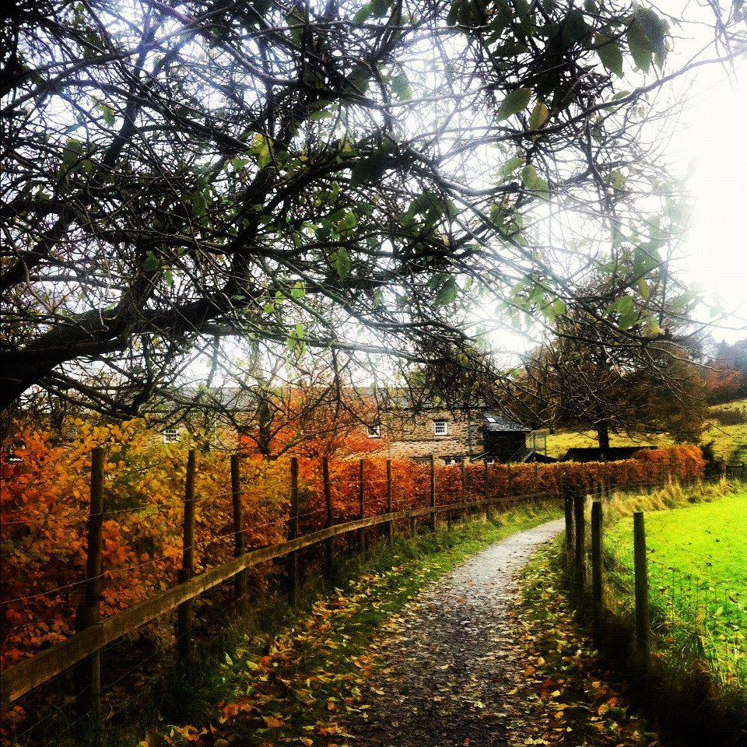

Four nights Monday 6th to Friday 10th October: Dinner, B&B £240.00 per person.
Four nights Monday 20th to Friday 24th October Dinner, B&B £240.00 per person.
Two nights Friday 10th to Sunday 16th November Dinner, B&B £110.00 per person.

